Information of the Corresponding Author

Title Dr. / Prof. / Mr. / Ms. / (please specify)
Name
Company/Institution
Job position
Mailing address

Telephone
E-mail
Are you a student? Yes / No
Preferred presentation type Oral / Poster / Either

Please send your abstract to sunlq@cup.edu.cn before Dec. 30, 2015. The acceptance notification will be sent to the corresponding author by Jan. 15, 2016. The presentation type will be eventually decided by the scientific committee.

This Is The Title Of Your Abstract, Font Size 14pt
Author 1 * (affiliation, email); Author 2 (affiliation); Author 3 (affiliation)
Please mark the speaker with an asterisk and include the corresponding author's contact information.

This is the information page and is not included in the 2-page limit of the abstract.

Summary

Click ONCE and select this paragraph, you will replace this text with your own text and it will be automatically formatted. All styles for this template are formatted for you.

This is the information page and is not included in the 2-page limit of the abstract.

Introduction

Click ONCE and select this paragraph, you will replace this text with your own text and it will be automatically formatted. All styles for this template are formatted for you.

Here is the second paragraph of the introduction. The font for this template is 11pt Times New Roman. The Section Headings are bold. The paragraphs are justified and separated by a blank line.

Abstracts will be printed on the memory stick and online exactly as they are submitted. EAGE staff will not edit or retype the copy.

Your abstract should be 1 to 2 pages long including all figures and references (if any), but exclude the information page(s).
Method/Theory
Additional instructions for composition are:
- Please write your abstract in English.
- Authors are responsible for sizing and positioning their illustrations (if any).
- Figures can be in black and white or colour.
- Embed into the text of the paper figures, equations, charts, graphics, etc.
These bulleted items are used as an example and should be deleted so they do not appear in your document.
Examples (Optional)
Each of the paragraphs and section headings appear shaded in this template, with the exception of the bulleted items above and the text in the following figure.

These text boxes appear shaded on the screen only. It will disappear as you select each paragraph to replace with your own text, or just delete.

If you have a chart, graphic, equation, etc. you will need to embed them in the document. Below is an example of a figure.
Conclusion
Font point sizes and line spacing should not vary from this template.
Acknowledgements (Optional)
The deadline for submitting your extended abstract is August 15, 2015.
References (Optional)
The lay-out of the references should be consistent with the style guide for references in the First Break guidance to authors. Please ensure every citation has a reference and vice versa.
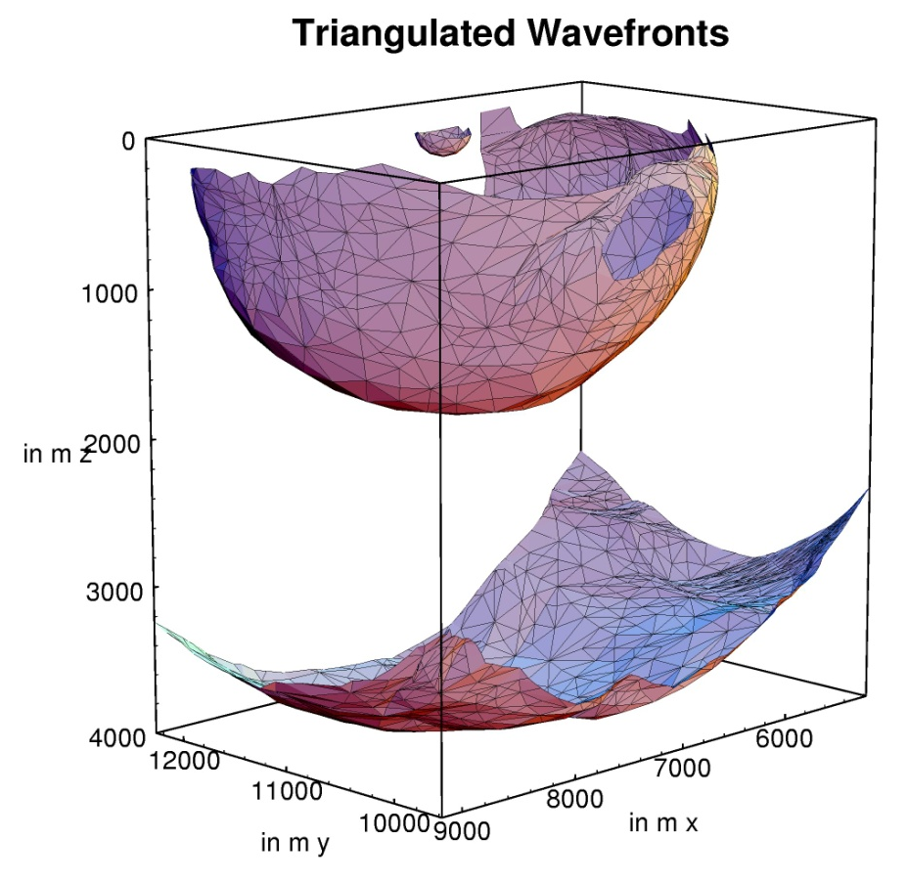
Figure 1 This is an example of a figure imported from jpeg (courtesy of Gilles Lambaré). Left click on Insert on the menu bar and then select Picture. You can also select to embed an object instead of a picture. You can either embed an existing file, or create your object at that point. Number the figures sequentially, according to their appearance in the text, and check that each figure is cited in the text. Supply a short caption for each figure; more detailed discussion of the figure can be reserved for the text. In this template figure caption is 11pt italic Times New Roman. Further information about the use of figure captions and figure numbering can be found in the First Break guidance to authors.

